Vincent van Gogh - The Bedroom
Student’s Name
University

Vincent van Gogh - The Bedroom
The painting ‘The Bedroom’ is one of Van Gogh’s painting. The artist produced this particular piece in 1889. Its dimensions are 73.6 × 92.3 cm, and Gogh used oil to paint on canvas. The detail within is a two-dimensional illustration of what Gogh’s bedroom looked at the time. The art work currently resides in the Art Institute of Chicago. With comparison of the Parisian paintings at the time, the piece was not as complex to meet expectations (Axford, 2017). However, the use of brushstrokes and color made ‘The Bedroom’ an authentic piece for the artist.
Color in the painting conveys the artist’s intention for rest. The thickness of the color and thickness of lines within the painting does not prompt much attention and study as opposed to Parisian paintings. Gogh also utilizes color to demonstrate and illustrate the depth and breadth of items in the painting. The bedside table, for instance, has a shade of blue to illustrate attention to structural integrity (Axford, 2017). The pillows, on the other hand, have thick white brushstrokes which demonstrate their thickness. The artists also portray unity in his technique through both lines and the dull colors adopted for surfaces, and also by avoiding shading. Van Gogh is successful in creating art which appeals emotionally to the audience.
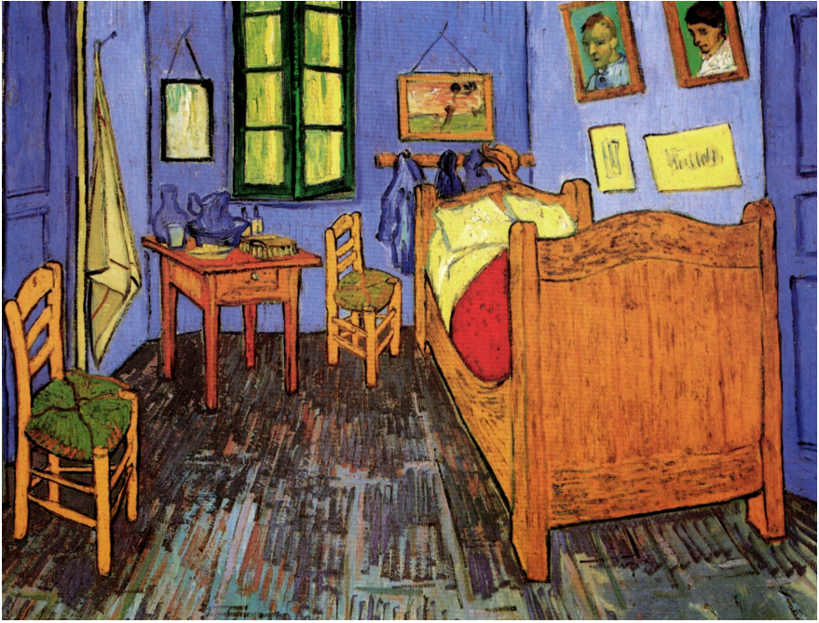
Figure 1: Vincent van Gogh - The Bedroom (73.6 × 92.3 cm)
References
Axford, M. (2017). Vincent van Gogh (In the Picture With). The School Librarian, 65(2), 114.

